**GITBASH DOWNLOAD LINK :-**  <https://github.com/git-for-windows/git/releases/download/v2.47.1.windows.1/Git-2.47.1-64-bit.exe>

**DOCKER DOWNLOAD LINK :-** <https://docs.docker.com/desktop/setup/install/windows-install/>

**FIGMA DOWNLOAD LINK :-** <https://www.figma.com/downloads/>

**Jira application link :-** <https://id.atlassian.com/>

**DOCKER**

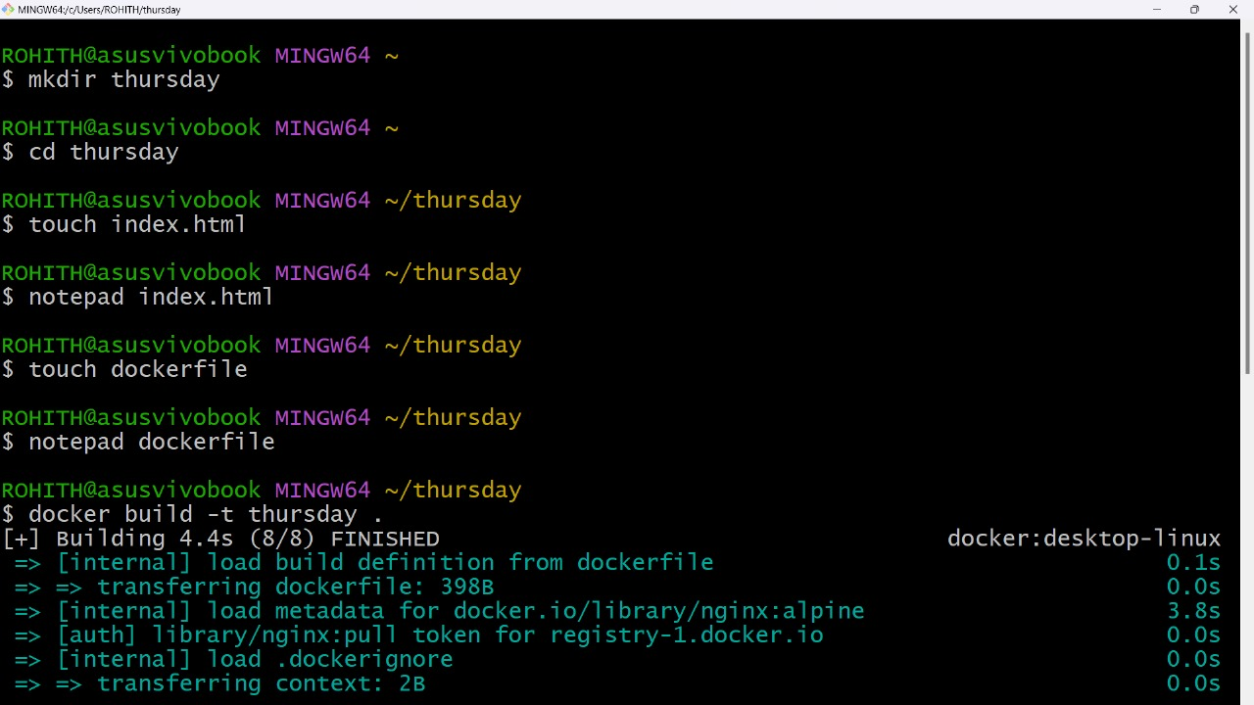

**index.html**

<!DOCTYPE html>

<html lang="en">

<head>

<meta charset="UTF-8">

<meta name="viewport" content="width=device-width, initial-scale=1.0">

<title>My Static Website</title>

</head>

<body>

<h1>Welcome to My Static Website</h1>

<p>This is a simple website served using Docker and Nginx.</p>

</body>

</html>

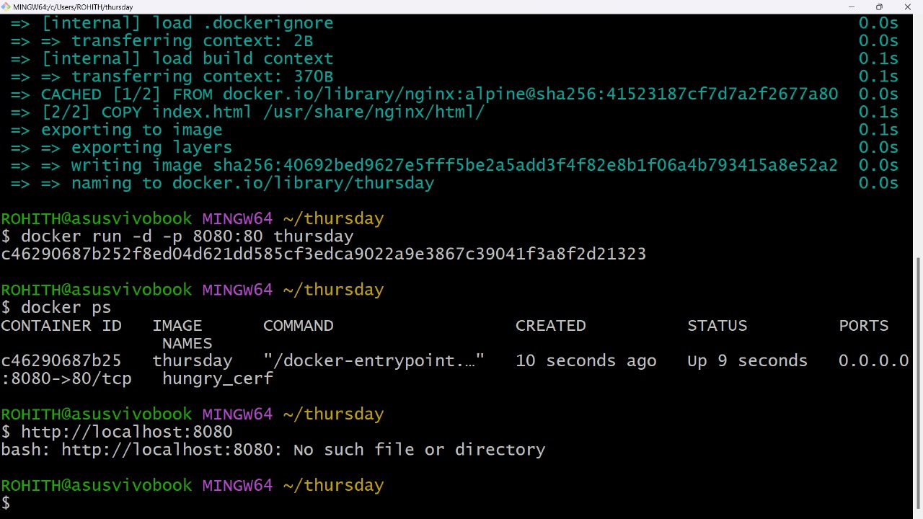**For docker**

# Use the official Nginx image from Docker Hub

FROM nginx:alpine

# Copy the index.html file into the Nginx default public directory

COPY index.html /usr/share/nginx/html/

# Expose port 80 to allow external access to the website

EXPOSE 80

# Run Nginx in the foreground (default command for the Nginx container)

CMD ["nginx", "-g", "daemon off;"]

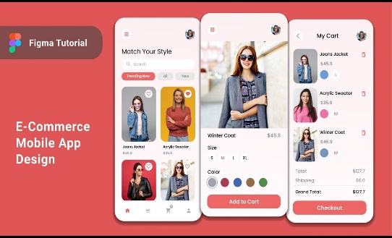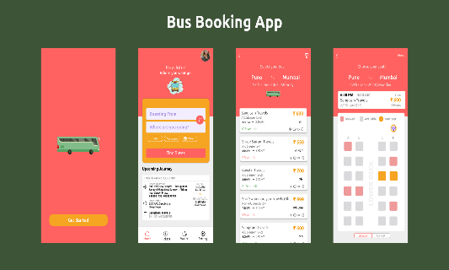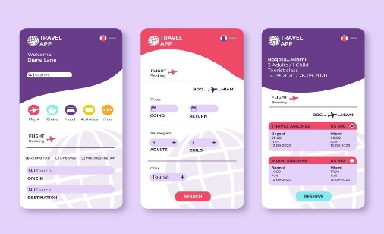FIGMA IMAGES:-



GITHUB/GITBASH:-

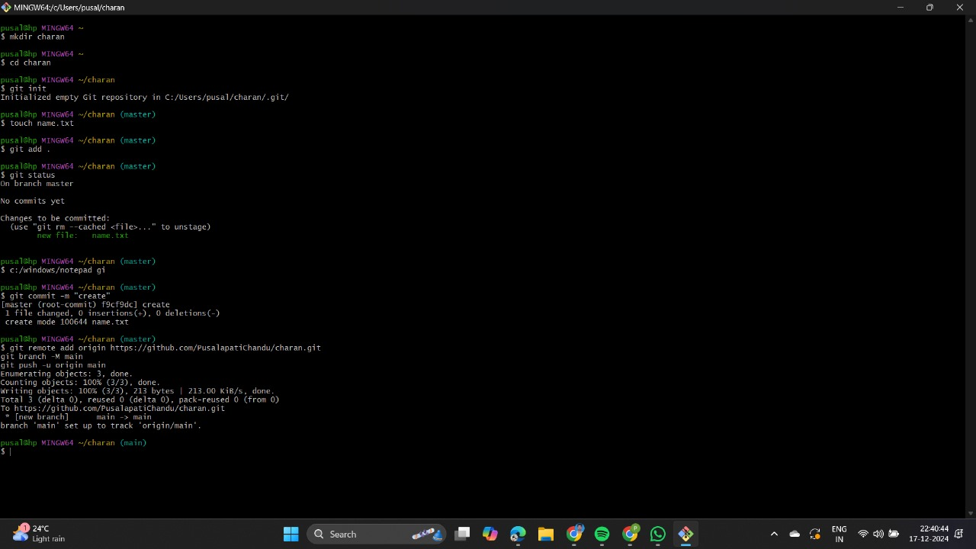

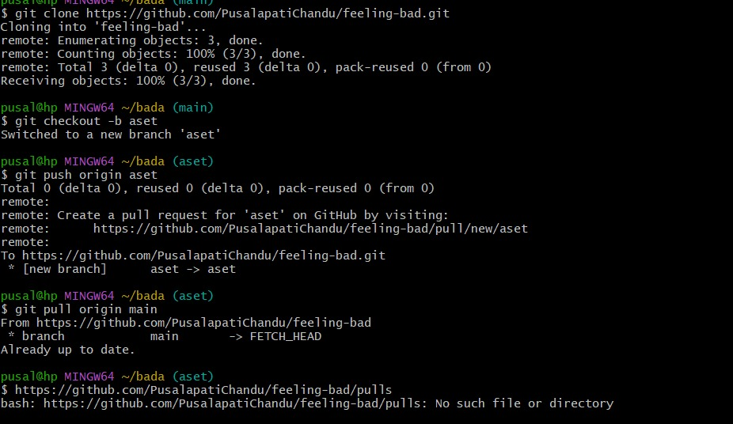

LIBRARIES MANAGEMENT SYSTEM using excel/google sheets :-

|  |  |  |
| --- | --- | --- |
| **Requirement** | **Category** | **Justification** |
| Search books by title and author | Must-Have | Core functionality for easy access to books. Critical for user experience. |
| Online book reservation system | Must-Have | Essential for enabling users to reserve books, improving accessibility and usability. |
| Generate monthly reports on borrowed books | Should-Have | Important for administrators but not essential for day-to-day user operations. |
| Email notifications for overdue books | Must-Have | Crucial for reminding users to return books on time, which improves book availability and user accountability. |
| QR code scanning for borrowing and returning books | Could-Have | A nice-to-have feature for added convenience and speed, but not critical for basic functionality. |
| User-friendly dashboard for librarians | Must-Have | A central feature to help librarians manage operations effectively, improving system efficiency. |
| Users can review and rate books | Should-Have | Useful for enhancing user interaction with books, but not essential for core functionality. |
| Integrate a chatbot for user assistance | Could-Have | Enhances user support and interaction, but could be considered non-essential depending on budget and resources. |
| Develop a mobile app version of the system | Should-Have | Expands accessibility but could be developed later, depending on budget and user needs. |
| Multi-language support | Could-Have | Adds inclusivity but can be implemented later as per need or resources. |